**Mohamed Abdi**

**Module Questions**

1. Review the Terms of Service (TOS) agreement for the GitHub service.
   * Open the link: (<https://help.github.com/articles/github-terms-of-service/>)
   * Summarize the section that confirms that you are permitted to use this software for this class.

* As long as you are at the age of 13 years of age you are allowed to use this program program.

Explain what rights do you give up by using this software.

* You give up Privacy, allowing an employee can have access to your repository/account when required. You give up your email address.
  + Explain what limitations you have when using this software.
* You can only use the software on a pc it is the only thing its compatible with. Anything you do/create on GitHub must be in compliance with local laws.

1. Review the Privacy Policy for the GitHub service.
   * Open the link: (<https://help.github.com/articles/github-privacy-statement/>)
   * **What information does GitHub collect and track?**

* GitHub only collects the basic and some personal information that is given by the user. They collect only info that is given by the user and is only processed with consent of the user.

Summarize how GitHub shares your information. GitHub also uses things like cookies for functionality of their website also with tracking and analytical services for better use .

GitHub only shares your info to provide the service to you, to help with your requests, or with vendors. They do not sell or share your information to anyone in any way or shape .

* + How does GitHub communicate with you?  
    GitHub contacts you through email but if you want to change the form of contacting to you phone number you can do so in profile settings

GitHub will be used to share course files in a similar way to My Class or D2L. The reason we are using GitHub is because this is the tool preferred by many software developers and is the most common way to share computer code on the internet.

The Peel School Board is concerned about the privacy and safety of its students and has issued the following guidelines for using third party applications:

* Do not provide: First & Last Name
* Do not provide: Birthday
* Do not provide: Personal Address & Contact Information
* Do not provide: Student Number
* Your @pdsb.net email address can be used but cannot be used as a login id.

1. Based on your understanding of the GitHub privacy policy, list two benefits and two drawbacks of following the Peel Board guidelines listed above.

* If you can't use your name it will be difficult for teachers to differ you repository from everyone else’s and since you cannot use an email with your name you will either have to make a new email or use or school email.
* Well if you don’t use your personal address or your birthday then it will be harder for hackers to determine who you are, where you live and how old you are if there is ever a data breach.

1. Create an account on GitHub.com following the Peel Board guidelines listed above.
   * **NOTE:** Make sure to select the free student plan when creating your account.

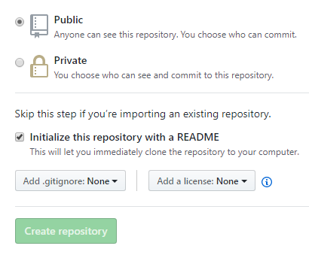

1. Create a new Repository for your ICS2O0 course work.
   1. Give your repository a meaningful name like “ICS2O0_Work”
   2. **Note:** Make sure to select "Public Repository"
   3. **Note:** Make sure to select “Include a ReadMe file”
2. Email Mr. Nestor (p0079141@pdsb.net) the following information:
3. Your Name
4. The link to your repository

Your personal GitHub repository will be used to store and manage your work for this course. You should save partially completed work in your repository and you can update it at any time from school or at home. GitHub automatically keeps track of updates to your files. You should NEVER make multiple VERSION COPIES of your work files.

Your repository should be shared with your teacher and with other members of your work group.

1. Open Mr. Nestor's repository for this class.
   * You should have bookmarked the link in an earlier part of this lesson.
   * This repository is the source for all course information and lesson files (much like D2L or Google Classroom is used by other teachers).
   * Note the structure and organization of Mr. Nestor’s repository. In particular, note the folders such as “Topic A”, "Topic B", etc.
2. Duplicate the organization structure and folder names in your personal repository.
   * Your personal GitHub repository will be used to upload and manage your work completed for this course.
   * Your repository needs to be well organized so that Mr. Nestor can easily find your work and give you credit for it.
   * **NOTE:** There is a “trick” required to create folders in GitHub.
   * See if you can find this trick and share it with your neighbours.
   * Check-in with Mr. Nestor to make sure you have found the trick.
3. Upload your answers to this module (i.e. the “A.1 Student - GitHub Repositories” )
   * Make sure to store it in the proper folder.
   * Use the "Upload" button in the GitHub screen and drag and drop you file.
   * Make sure to "Commit" your changes at the bottom of the upload screen.
   * You can upload and commit partially completed work now and then upload the same file again at a later time; GitHub automatically keeps track of your changes.

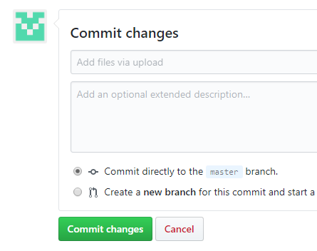

1. Email Mr. Nestor ([p0079141@pdsb.net](mailto:p0079141@pdsb.net)) when you have completed this work.

Work will be submitted (handed in) by uploading it to your repository . ONLY work uploaded to your repository will be considered handed in and will be marked.